**DBMS KEY Milestone 2**



**Spring 2025**

**CSE 403L: DATA BASED MANAGEMENT SYSTEM**

**Group members:**

**Muhammad Maaz(22PWCSE2204)**

**Muhammad Ibad Khan (22PWCSE2170)**

**Muhammad Talha Khan(22PWCSE2213)**

**Class Section: A**

“On my honor, as student of University of Engineering and Technology, I have neither given nor received unauthorized assistance on this academic work.”

**Submitted to:**

**Engr. Maam Sumayyea Salahudin**

**DATED: 7/8/2025**

**Department of Computer Systems Engineering**

**University of Engineering and Technology, Peshawar**

1. **Converting Conceptual Schema (EER Diagram) to Relational Schema):**

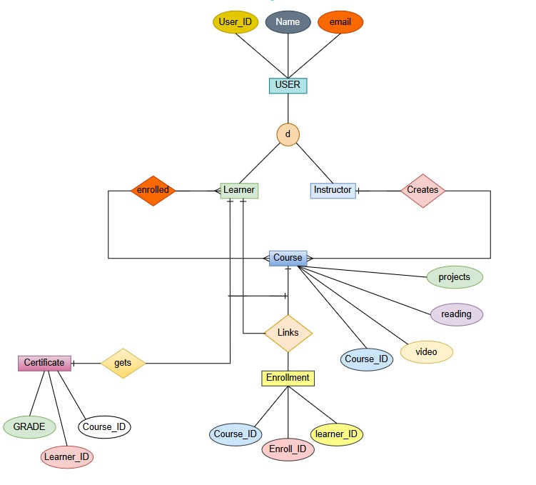

**Relational Schema:**

**MAPPING FOR LARAVEL**

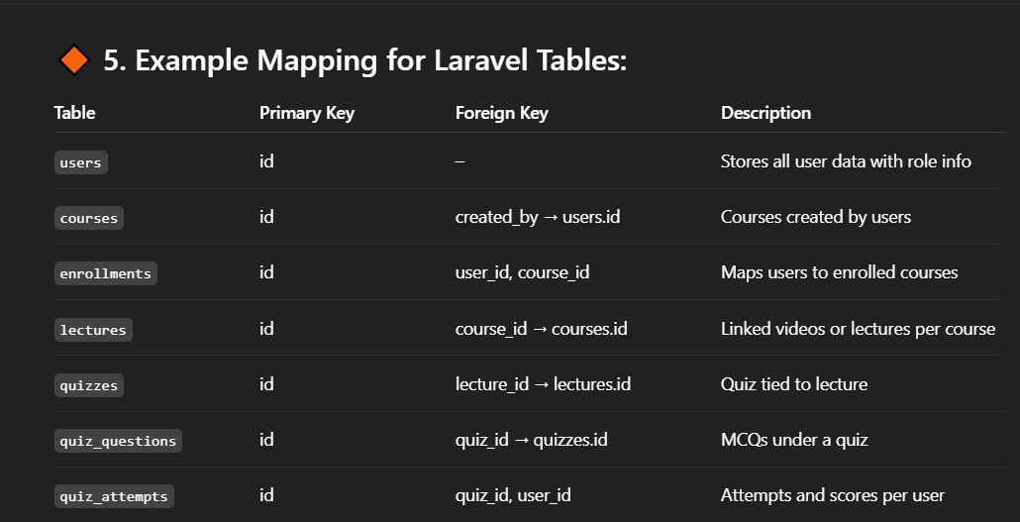

1. **USER:**

* **Attributes:**
  + User_ID (Primary Key)
  + Name
  + Email

1. **Learner:**

* **Attributes:**
  + User_ID (Primary Key)
* **Constraints:**
  + Foreign Key referencing USER(User_ID)

1. **Instructor:**

* **Attributes:**
  + User_ID (Primary Key)
* **Constraints:**
  + Foreign Key referencing USER(User_ID)

1. **Course:**

* **Attributes:**
  + Course_ID (Primary Key)
  + Projects
  + Reading
  + Video

1. **Enrollment:**

* **Attributes:**
  + Enroll_ID (Primary Key)
  + Learner_ID (Foreign Key referencing Learner(User_ID))
  + Course_ID (Foreign Key referencing Course(Course_ID))

1. **) Certificate:**

* **Attributes:**
  + Course_ID (Primary Key, Foreign Key referencing Course(Course_ID))
  + Learner_ID (Primary Key, Foreign Key referencing Learner(User_ID))
  + Grade

**1st Normal Form:**

**USER**

(User_ID PRIMARY KEY, Name, Email)

**Learner**

(User_ID PRIMARY KEY REFERENCES USER(User_ID))

**Instructor**

(User_ID PRIMARY KEY REFERENCES USER(User_ID))

**Course**

(Course_ID PRIMARY KEY, Title, Description)

PRIMARY KEY (Course_ID, Video_ID))

**ENROLLMENT**

(Enroll_ID PRIMARY KEY,

Learner_ID REFERENCES Learner(User_ID),

Course_ID REFERENCES Course(Course_ID),

Enrollment_Date,

Status)

**CERTIFICATE**

(Cert_ID PRIMARY KEY,

Enroll_ID REFERENCES ENROLLMENT(Enroll_ID),

Issue_Date,

Expiry_Date).

2nd Normal Form:

**USER**(User_ID PRIMARY KEY, Name, Email, User_Type)

**LEARNER(User_ID PRIMARY KEY REFERENCES USER(User_ID))**

**INSTRUCTOR**(User_ID PRIMARY KEY REFERENCES USER(User_ID))

**COURSE**(Course_ID PRIMARY KEY, Title, Description, Instructor_ID REFERENCES INSTRUCTOR(User_ID))

**ENROLLMENT**(

Enroll_ID PRIMARY KEY,

Learner_ID REFERENCES LEARNER(User_ID),

Course_ID REFERENCES COURSE(Course_ID),

Enrollment_Date,

Status,

UNIQUE (Learner_ID, Course_ID) -- Prevent duplicate enrollments

)

**CERTIFICATE**(

Cert_ID PRIMARY KEY,

Enroll_ID REFERENCES ENROLLMENT(Enroll_ID), -- Now depends on single enrollment

Issue_Date,

Expiry_Date)

**3rd Normal Form:**

USER(

User_ID PRIMARY KEY, -- Unique identifier for all users

Name, -- User's full name

Email UNIQUE, -- User's email (must be unique)

User_Type CHECK (User_Type IN ('Learner', 'Instructor')) -- Role type

)

LEARNER(

User_ID PRIMARY KEY -- Inherits from USER

REFERENCES USER(User_ID) -- Foreign key to USER table

ON DELETE CASCADE, -- If user is deleted, learner record is too

-- Additional learner-specific attributes can be added here

)

INSTRUCTOR(

User_ID PRIMARY KEY -- Inherits from USER

REFERENCES USER(User_ID) -- Foreign key to USER table

ON DELETE CASCADE, -- If user is deleted, instructor record is too

-- Additional instructor-specific attributes can be added here

)

COURSE(

Course_ID PRIMARY KEY, -- Unique course identifier

Title, -- Course title

Description, -- Course description

Instructor_ID -- Who teaches this course

REFERENCES INSTRUCTOR(User_ID) -- Foreign key to INSTRUCTOR

ON DELETE RESTRICT, -- Prevent deletion if courses exist

Creation_Date,

Is_Active BOOLEAN

)

ENROLLMENT(

Enroll_ID PRIMARY KEY, -- Unique enrollment identifier

Learner_ID -- Who is enrolling

REFERENCES LEARNER(User_ID) -- Foreign key to LEARNER

ON DELETE CASCADE, -- Delete if learner is deleted

Course_ID -- Which course they're enrolling in

REFERENCES COURSE(Course_ID) -- Foreign key to COURSE

ON DELETE CASCADE, -- Delete if course is deleted

Enrollment_Date, -- When enrollment occurred

Status CHECK (Status IN ('Active', 'Completed', 'Dropped')), -- Enrollment state

UNIQUE (Learner_ID, Course_ID) -- Prevent duplicate enrollments

)

CERTIFICATE(

Cert_ID PRIMARY KEY, -- Unique certificate identifier

Enroll_ID -- Which enrollment this certifies

REFERENCES ENROLLMENT(Enroll_ID) -- Foreign key to ENROLLMENT

ON DELETE CASCADE, -- Delete if enrollment is deleted

Issue_Date, -- When certificate was issued

Expiry_Date, -- When certificate expires

Certificate_URL -- Link to digital certificate

)

**References:**

* www.Deepseek.com
* [www.github.com](http://www.github.com)

THE END